
JC2 PRELIMINARY EXAMINATION
TAMPINES MERIDIAN JUNIOR COLLEGE

CANDIDATE
NAME
CIVICS GROUP
_________________________________________________________________________________
H2 GEOGRAPHY 9173/01
Paper 2 16 September 2024 3 Hours
Additional Materials: 12 Page Answer Booklet
1 Insert ____________________________________________________________________________

READ THESE INSTRUCTIONS FIRST

Write your answers in the answer booklet provided. You should follow the instructions on the front cover of the answer booklet. If you need additional answer paper, ask the invigilator for a continuation booklet.

Answer all questions.

The Insert contains all the Resources referred to in the questions.
You should make a reference to appropriate examples studied in the field or the classroom, even where the examples are not specifically requested by the question.
Diagrams and sketch maps should be drawn wherever they serve to illustrate an answer.
You are reminded of the need for good English and clear presentation in your answers.

The number of marks is given in the brackets [ ] at the end of each question or part question.

______________________________________________________________________
This document consists of 5 printed pages

Answer Questions 1 and 2 and
EITHER Question 3 OR Question 4

Section A

Cluster 4: Fieldwork

1 | (a) | Explain how the students can minimise potential risks they might encounter when conducting their fieldwork in the two neighbourhoods shown in Resource 1. |  | [5]
- Student can minimize potential risk to themselves by working in groups as they are in a foreign country, so they must always work in groups to look out for each other to call for help when there are potential danger such as being harassed by foreigners.

- Students should also always stay on the side of the roads, especially in Sanya as it does not look like there are designated clear pathways between paths and roads so they need to look out for traffics when trying to conduct the survey or doing their environmental study.
 | (b) | Using resource 1, explain how students can minimise potential ethical issues faced when conducting their fieldwork in both neighbourhoods. |  | [4]
- Should not pressure or force the elderly to do their survey if they do not want to do it, ask them nicely and explain their intention of doing the survey.
- Should not take photos that clearly show the faces of elderly without their permission, as this infringes on their personal privacy and they do not know what the photos might be used for and where it will be published especially without their consent.
- Do not ask sensitive questions such as name and age in their questionnaire survey

 | (c) | Describe an appropriate sampling method for the students to collect residents response on the residents’ perception of quality of life in Sugamo and Sanya. |  | [6]
- Appropriate sampling method would be stratified sampling
- Decide on sample size, need to be more than 30 per neighborhood to be statistically significant
- Split elderly into men/women, different age groups
- Go to different parts of Sugamo and San’ya, check if they are residents in the district before getting them to engage in the questionnaire
- Go on different days and times to ensure it is more reliable and representative.
 | (d) | With reference to Resource 2, suggest two reasons why the environmental survey results differ between the residents and the students in Resource 3. |  | [4]
- Subjectivity of the survey questions, what is considered good housing design may differ from students to elderly living there

- Students may not have enough understanding of the noise and traffic of different times of the day/year so their perception is only based on a particular time where they visit compared to the elderly residents who may have lived there for a long time
 | (e) | Sketch a suitable representation of the students’ results for Sugamo and Sanya from Resource 3. |  | [5]
 | 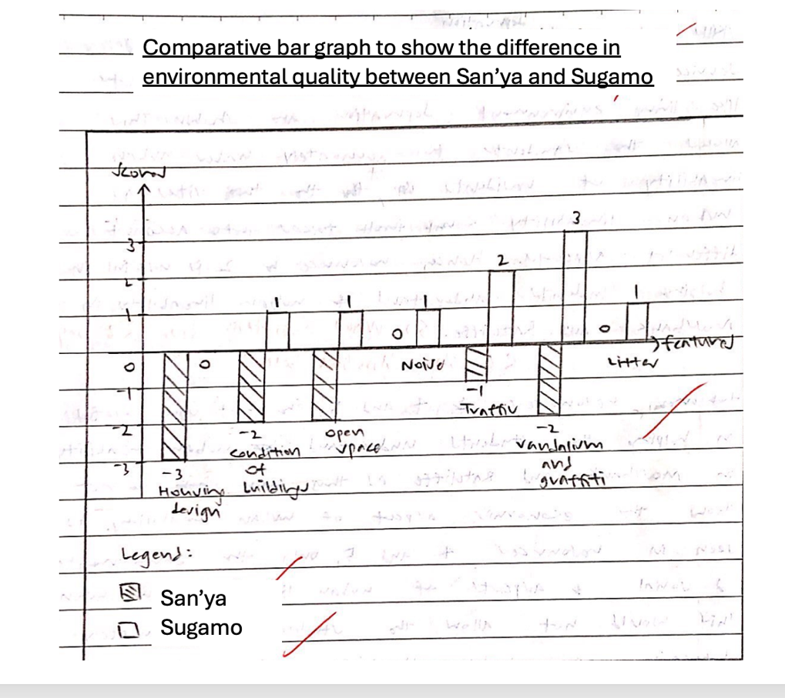
 | (f) | Suggest three potential limitations arising from the survey results from the residents’ perception of quality of life in Sugamo and San’ya. |  | [6]
- Residents may not understand English and did not fill up the survey properly, which affects the reliability of the data.

- Residents may have different perception or understanding of some of the survey questions used like community spirit/ or what is good or satisfactory can be subjective, affecting accuracy of the data.

- Small sample size of 25 residents is not representative, or only doing it within a week is not representative as other residents are not around, so not statistically significant (not reliable).
 | (g) | Evaluate the usefulness of Resources 1, 3 and 4 in helping students understand factors affecting liveability in Sugamo and San’ya and suggest which hypothesis should be accepted. |  | [10]
Students can discuss the usefulness and reasons why certain data as not as useful.
Ultimately their conclusion should point towards accepting the hypothesis from Group A.

Cluster 3: Sustainable Future and Climate Change

2 | Resource 5 shows the population growth of the world’s 8 largest cities.  Resource 6 shows the changes in Marina Bay Area, Singapore.  Resource 7 shows the liveability city ranking for selected cities.
 | (a) | Using Resource 5, describe the change in urban population growth for the world’s 8 largest cities from 1950 to 2035 | [4]
- All 8 cities experience an increase
- Paris has the smallest increase from 1950 to 2035 by about 5 million people
- Delhi is projected to have the largest increase and it will be the only city to be above 40 million people in 2035
- From 1950 to 2024, Tokyo had the largest increase of 25million
- Mostly LDC cities increasing more

 | (b) | With reference to Resource 5, explain the forecasted UN Projection of the world’s 8 largest cities in 2035. | [6]
Reasons for urbanisation
- Rural-Urban Migration in LDCs cities
- Large scale natural increase in LDC Cities
- Popular attractive international migration in DC cities like Paris, Tokyo, New York- Newark
 | (c) | Using Resource 6, describe the changes shown in the Marina Bay area. | [4]
- Increase in building density
- More infrastructure even on the bay (e.g. floating platform) or expansion and building into the bay
- Less green spaces as they are replaced by buildings and iconic architecture
- Increased construction of roads and bridges

 | (d) | Explain the economic reasons for cities to engage in urban reimaging efforts. | [6]
- Regenerate economy transition from manufacturing to service sector
- Increase global competitiveness with adequate infrastructure
- Make city attractive for tourism

 | (e) | Using Resource 7, describe the change in liveability ranking for selected cities. | [4]
- Tokyo consistently remained as the most liveable city from 2013 to 2023
- Kyiv experienced the largest drop in liveability ranking from around 170 place in 2013 to 230 place in 2023
- Khartoum decreased in liveability ranking, but it was also the lowest ranked from 2013 to 2023
- Tbilisi have the largest increase in liveability ranking from 2013 to 2023
 | (f) | Explain the factors that could have led to a change in the liveability rankings for the cities shown in Resource 7. | [6]
Social, Economic, Environmental, Political factors – either improve or regression
- Social instability due to political conflict with Russia cause Kyiv to regress the most in liveability ranking from 2013
- Social/political instability and poor economy cause Khartoum in Sudan to always rank last
- Strong economic conditions, good living environment cause Tokyo to always remain top

Section B
Answer either Question 3 or Question 4

Cluster 3: Sustainable Future and Climate Change

3 | Evaluate the extent to which we can measure Sustainable Urban Development. | [20]
 | Students can discuss how SUD can be measured using single dimension and composite indicators and why are they important. Students can then discuss the flaws of measuring through such indicators and whether these flaws and issues can be overcome with more advance benchmarks like Bellagio Stamp.
4 | Evaluate the challenges in implementing strategies to respond to climate change. | [20]
 | Students can discuss the various challenges for climate change such as political and economic challenges. Students can discuss how the main challenge may vary from country to country or students can discuss if the impact of climate change can also create uncertainty and confusion in trying to respond to climate change.

[End of Paper]

